**India’s Agricultural Crop Production**

**Analysis(1997-2021)**

Introduction:

Brief overview of the importance of agriculture in India's economy.

Mention the significance of crop production analysis for policy formulation and sustainable development.

Historical Perspective (1997-2021):

Overview of major crops and their production during this period.

Highlight significant fluctuations, growth trends, and regional disparities.

Factors Affecting Crop Production:

Climate and weather patterns (monsoons, droughts, floods) and their impact on crop yields.

Soil health, land use, and irrigation patterns.

Technological advancements in agriculture (e.g., GM crops, precision farming, mechanization) and their influence.

Policy Interventions and Reforms:

Analyze major agricultural policies and reforms during the period.

Evaluate their impact on crop production, farmer income, and overall agriculture growth.

Crop-wise Analysis:

Analyze the production trends and challenges for major crops like rice, wheat, pulses, fruits, vegetables, etc.

Discuss the impact of technology adoption, market demand, and export trends on specific crops..

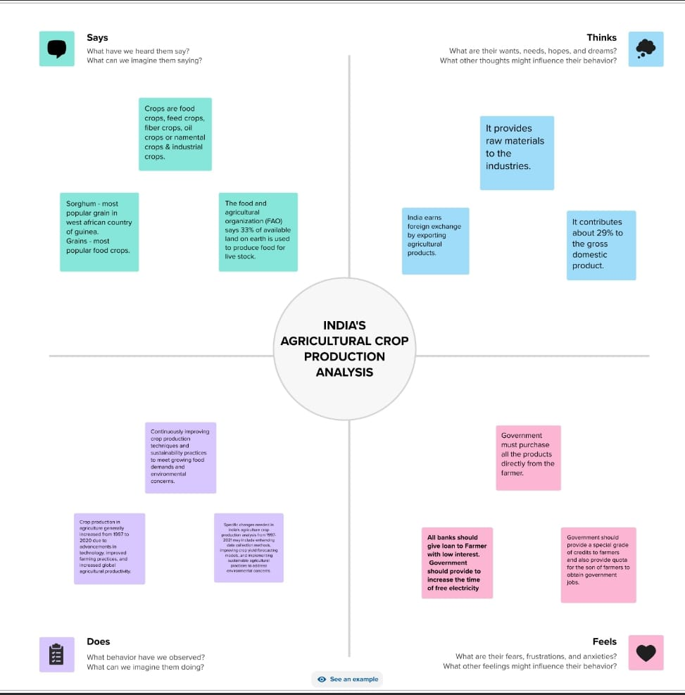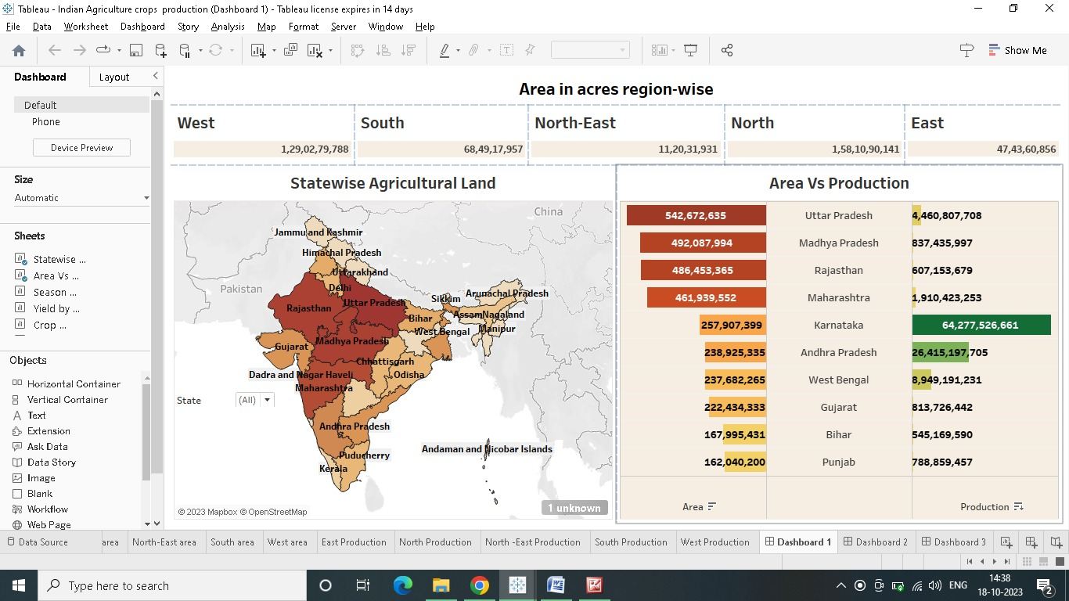

**RESULTS:**

Discuss sustainable agriculture practices and their role in mitigating climate change effects.

Challenges and Future Prospects:

Identify challenges faced by the Indian agriculture sector during the period.

Discuss potential solutions and future prospects for sustainable crop production.

Conclusion:

Summarize the key findings and insights from the analysis.

Highlight the importance of continuous monitoring, technology adoption, and policy support for enhancing crop production in Indian agriculture.

Recommendations:

Provide recommendations for policy improvements, research focus areas, and farmer-centric initiatives to boost crop production and ensure food security in the future.

Remember to support your analysis with data, graphs, and case studies to enhance the credibility and comprehensiveness of the report.